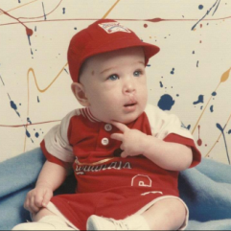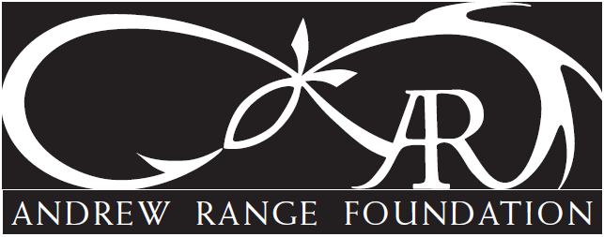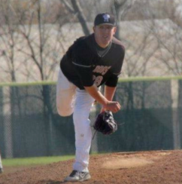

On Saturday, June 18, 2022 the 4th Andrew Range Memorial Golf Tournament will be held at Fox Creek Golf Course in Edwardsville!!!

In preparation for this year’s event, we ask that you become one of our generous sponsors by donating either a $200 Hole Sponsorship or donate an item for the silent auction by filling out and returning the attached sheet.

The thriving Andrew Range Golf Memorial Fund was established to give to the Andrew Range Foundation – a 501c3 organization established to pay forward Andrew’s positive influence.

The 2021 Andrew Range Memorial Golf Tournament, Dinner and Silent Auction was once again a sold-out event of over 250 individuals. Due to the generosity over the past 3 years with over 300 sponsorships, the tournament has helped to raise over $50,000 for the Andrew Range Foundation.

Since the inception of the foundation in 2018, we have been able do some amazing things on behalf of Andrew. Specifically:
- In 2020 and 2021, issued a Premier-level ($10,000 each year) donation to Smile Train, the world leading cleft charity. These donation amounts enable approximately 40 cleft surgeries and support care including social workers, speech therapist, dentists and more to children in need around the world. *
- Awarded 6 $1000 scholarships to Triad High School players. *
- Fully met Endowment Level Scholarship at Truman State University and awarded 4 scholarships. *
- Fully met Endowment Level Scholarship at Southern Illinois University at Carbondale Law and awarded 3 scholarships. *
- Donated start-up expenses for kuvnyl.com – a 501c3 organization to work with inner-city youth to teach them how to bow hunt and eventually participate in a bow hunt.
- Hosted a collection of gently used sports equipment and donated over a truckload of equipment for under-served St. Louis youths.
- Gifted ‘Basket of Healing’ packages for impacted parents and siblings.
- And more!
* Annotates Annual Foundation Commitment

For more information, please see https://www.andrewrangefoundation.com/golf-tournament or call Dawn Schmidt at 618-795-4502.

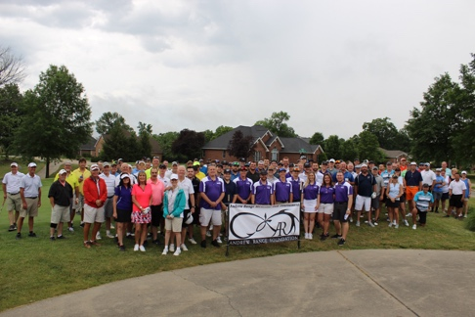
ANDREW RANGE MEMORIAL FOUNDATION
THIRD ANNUAL GOLF TOURNAMENT (June 18, 2022)
COMPANY NAME: ___________________________________________________
CONTACT PERSON: __________________________________________________
PHONE NUMBER: ___________________________________________________
YES, I would like to contribute:
____________ $200 Hole Sponsorship (will include company name/logo)
____________ Silent Auction Item (will need by 6/10/22)
Please Specify: ___________________________________________
Approximate Value: _______________________________________
Please make check for hole sponsorship to:
Andrew Range Memorial Golf
Mail checks and/or auction items to: Dawn Schmidt
4772 Drda Ln
Edwardsville, IL 62025

We can also pick up any silent auction items.
THANK YOU SO MUCH FOR HELPING TO MAKE THIS MEMORY OF ANDREW A SUCCESS!!!
The Andrew Range Memorial Fund (Registration ID is 82-3955195) is federally registered/approved (501c3)

